|  |  |  |  |
| --- | --- | --- | --- |
| Name:  Class: | ____________________________________  ________________ | | Date:_________ |
|  | **Year 11 Essential Mathematics**  / 49  6 %  **Major Test 2 2018**  **Topic - Measurement** | | |
| **Total Time:** | 55 minutes |  | |
| **Weighting:** | 6% |
| **Equipment:** | To be provided by the student: Pen, pencil, ruler,1 double sided A4 page of notes, scientific calculator | | |

**Full working out must be shown to get full marks. Attempt all questions.**

|  |
| --- |
| **Question 1** **3 marks** |

Circle the correct answer.

1. Choose the largest length. 22 mm 2 cm 2.5 cm
2. Indicate the smallest capacity. 0.057 kL 5700 mL 570 L
3. Which is the largest volume? 2.3 m3 2300 cm3 23 000 mm3

|  |
| --- |
| **Question 2** **8 marks** |

Convert the following to the units of measurement indicated.

|  |  |
| --- | --- |
| 1. 50cm = ___________ m | e) 73 000 cm2 = _________ m2 |
| 1. 6 km = ____________ m | f) 0.8 m2 = __________ mm2 |
| 1. 5000 m = ___________ km | g) 35cm3 = __________ mL |
| 1. 0.05 m = ___________ m | h) 20 L = ____________ cm3 |

|  |
| --- |
| **Question 3** **6****marks** |

Choose an appropriate unit of measurement for the following quantities

* 1. Length of the Kwinana Freeway. ________________
  2. The amount of carpet needed to carpet a classroom. _______________
  3. The height of a mug. _______________
  4. The size of the largest cattle station in the Pilbara. ________________
  5. The length of a baby ant. _______________
  6. The amount of space taken up by a bowling ball. _______________

|  |
| --- |
| **Question 4****8****marks** |

Determine the perimeter of the following shapes.

a) b)

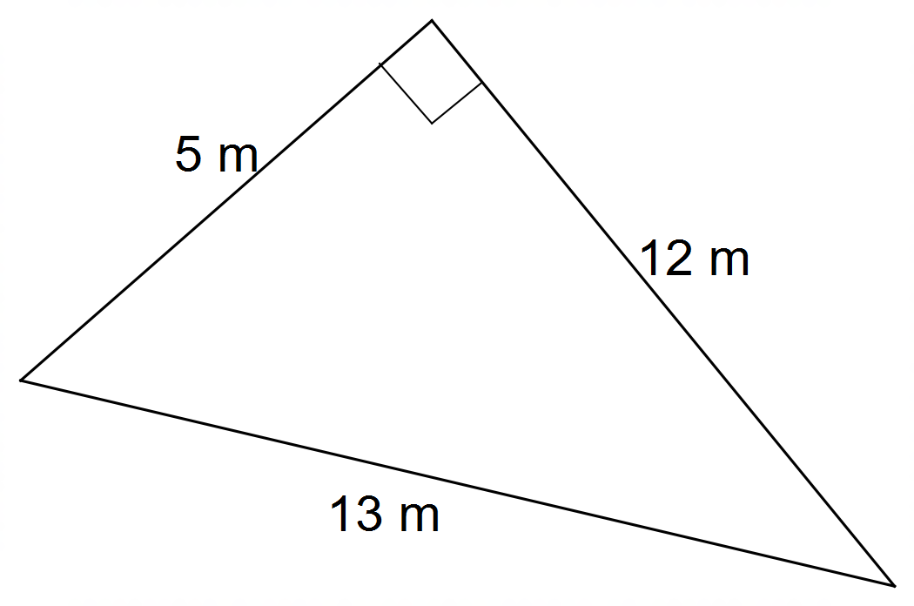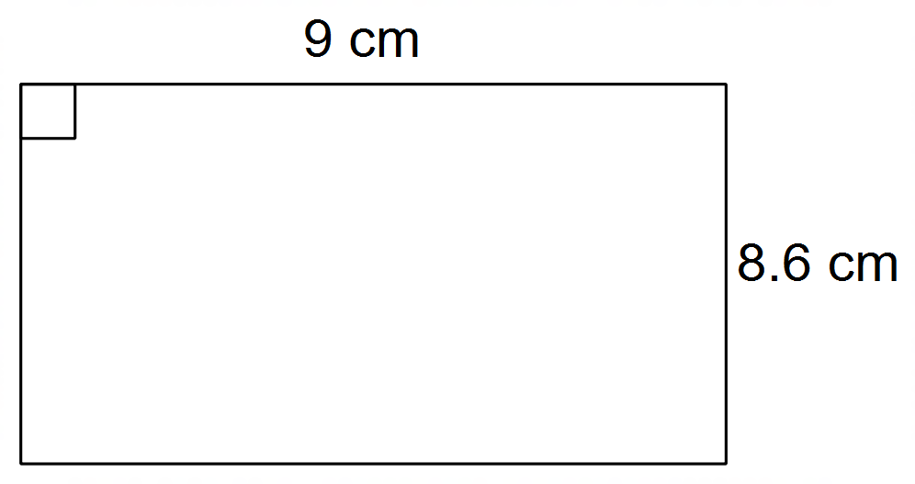

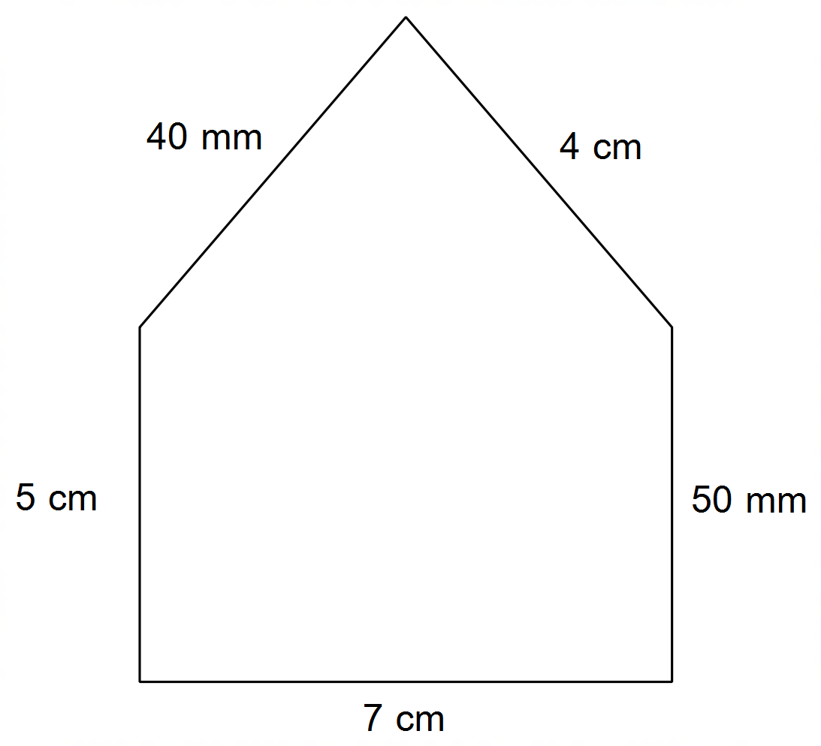

c) d)

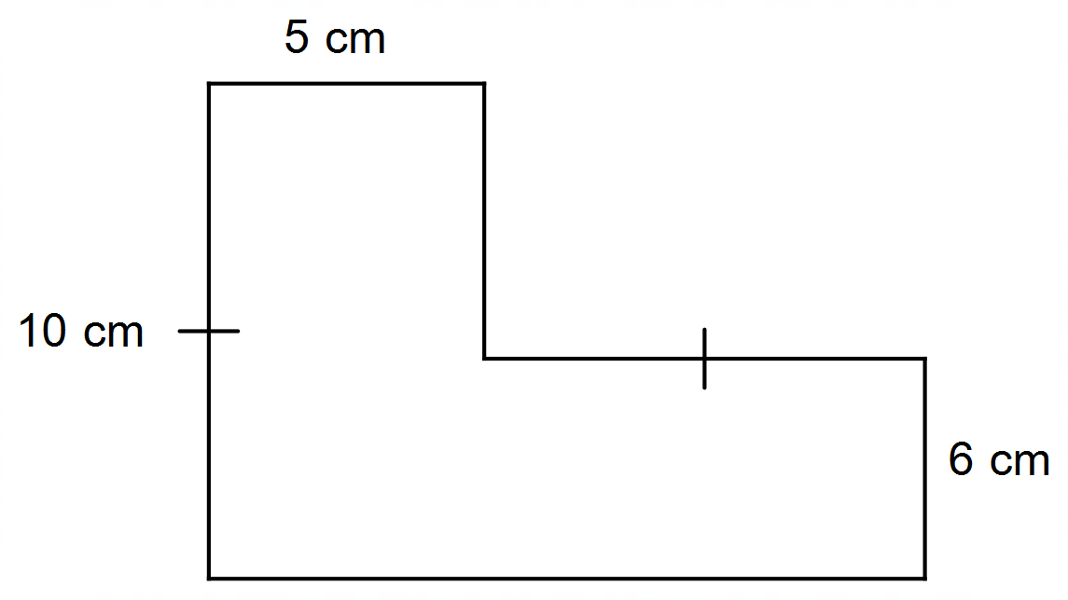

|  |
| --- |
| **Question 5** **7 marks** |

Find the area of the following shapes:

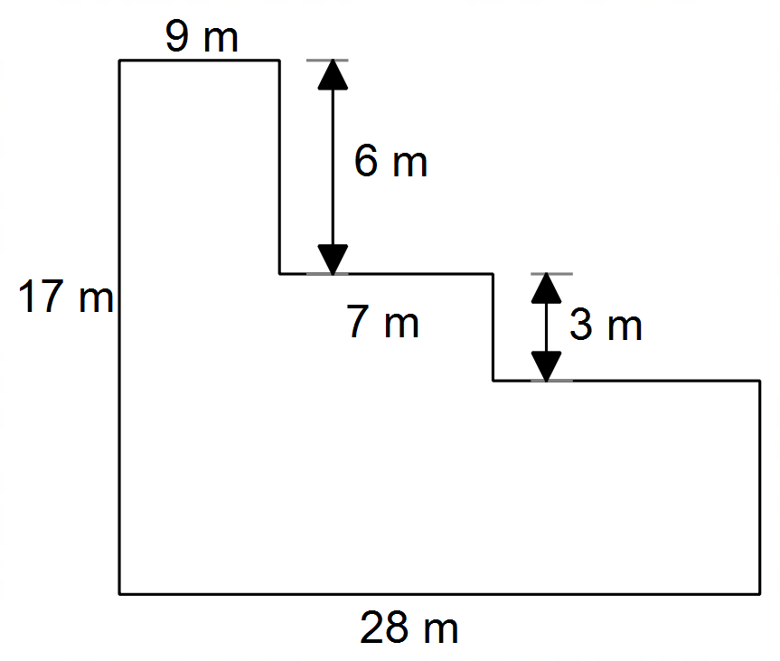a) b)

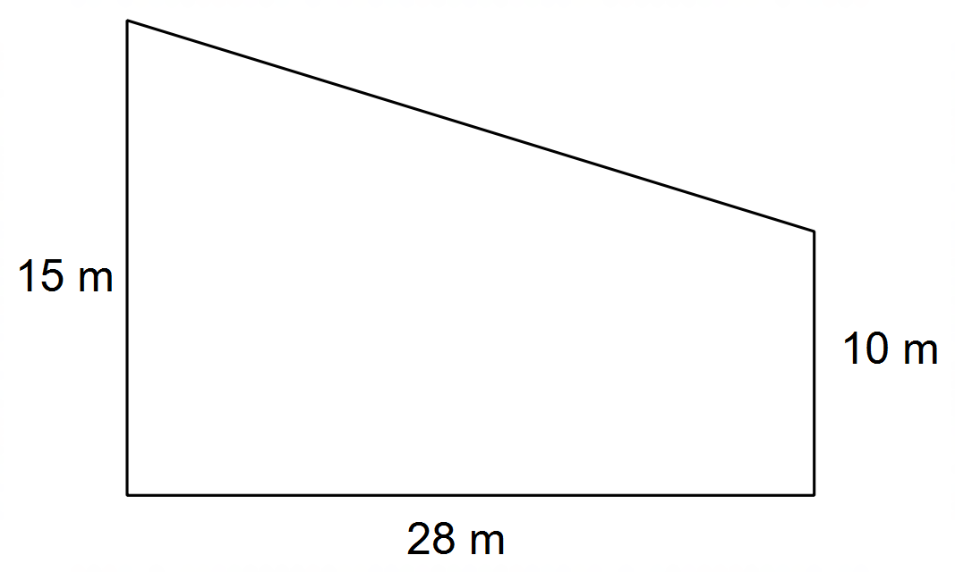

|  |
| --- |
| **Question 6** **3 marks** |

Calculate the volume of the following solids

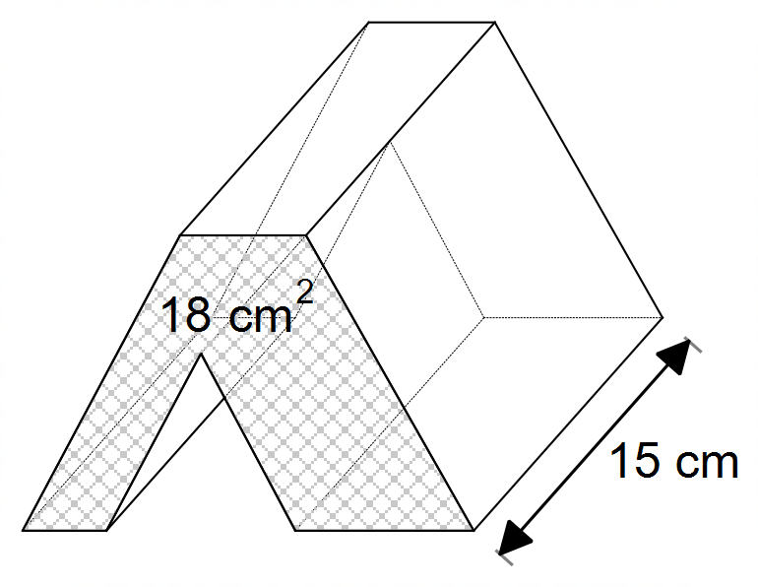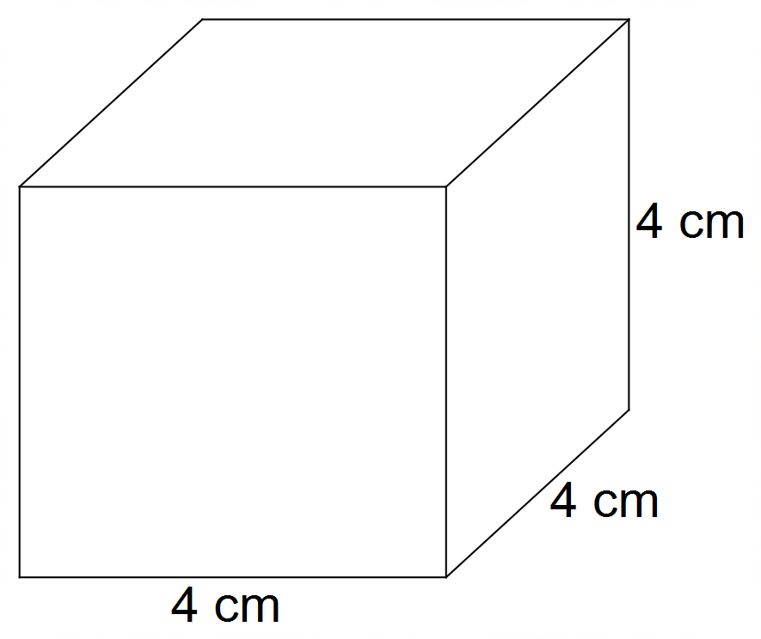a) b)

|  |
| --- |
| **Question 7** **5****marks** |

The boundary lines of a tennis court have faded and need to be repainted. The court is rectangular and is 24 m long and 8.5 m wide.

a) Calculate the perimeter of the court.

b) It takes a painter 0.5 L to paint 1 m of the line. How much paint will he need?

c) If the paint comes in tins of 4L, how many tins will be required?

d) Each paint tin costs $40. How much will the painting of the lines cost?

|  |
| --- |
| **Question 8** **7****marks** |

A pool is being installed into Darcy’s backyard. The pool has a length of 10 metres, width of 5 metres, and is 1.5 metres deep. Darcy’s backyard is 15m in length and has a width of 8m. Before the pool can be installed, the local council has requested that Darcy provides information that the pool will fit in the backyard. The pool will also have 1 metre paving tiles around its perimeter.

a) Provide Darcy with the calculations and information to determine if the pool will fit in the backyard with the paving.

b) The council has also requested information on the amount of soil that will be removed from Darcy’s backyard for the pool installation. Show how you would calculate this.